**Activity 1 – Creating Column Charts**

Consider the Cheetah Sports regional sales data included in the CheetahRegion data

file shown below.

Open the CheetahRegion sports sales data file and create a column chart using the

following steps:

• Step 1. Select cells A1:B11

• Step 2. Click the Insert tab on the Ribbon.

• Step 3. In the Charts group, click the Insert Column or Bar Chart button

• Step 4. Select Clustered Colum

**This is my Column chart:**

**Activity 2 – Creating a Line Chart**

[**Link to My Excel Dashboard**](module%202%20workshop/CheetahRegion%20Chart.xlsx)

Q. **Why does the stacked column chart make the preferred data visualisation choice over the clustered column chart?**A stacked column chart is often preferred over a clustered column chart due to its superior ability to visually illustrate and compare different sections within distinct categories. On the other hand, clustered column charts are good idea for comparing absolute values across categories, with no emphasis on part-to-whole correlations, also decisions should be made depending on the type of data and the desired insights. In addition, there are many reason why stacked column chart might be the better choice: Relationship between two parts, Makes it simple to compare total values across categories by visually comparing column heights, due to they are stacked on top of each other, easy to compare and limited of number of Comparing.

**Activity 3 – Interpreting Charts**

Consider the New York City Budget Allocation case shown in the graphs on this page

and the next.

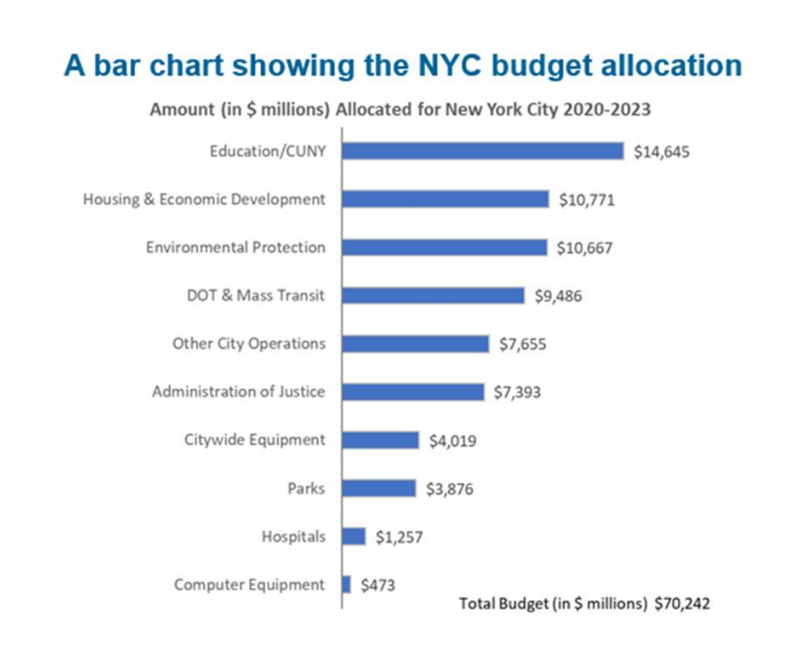

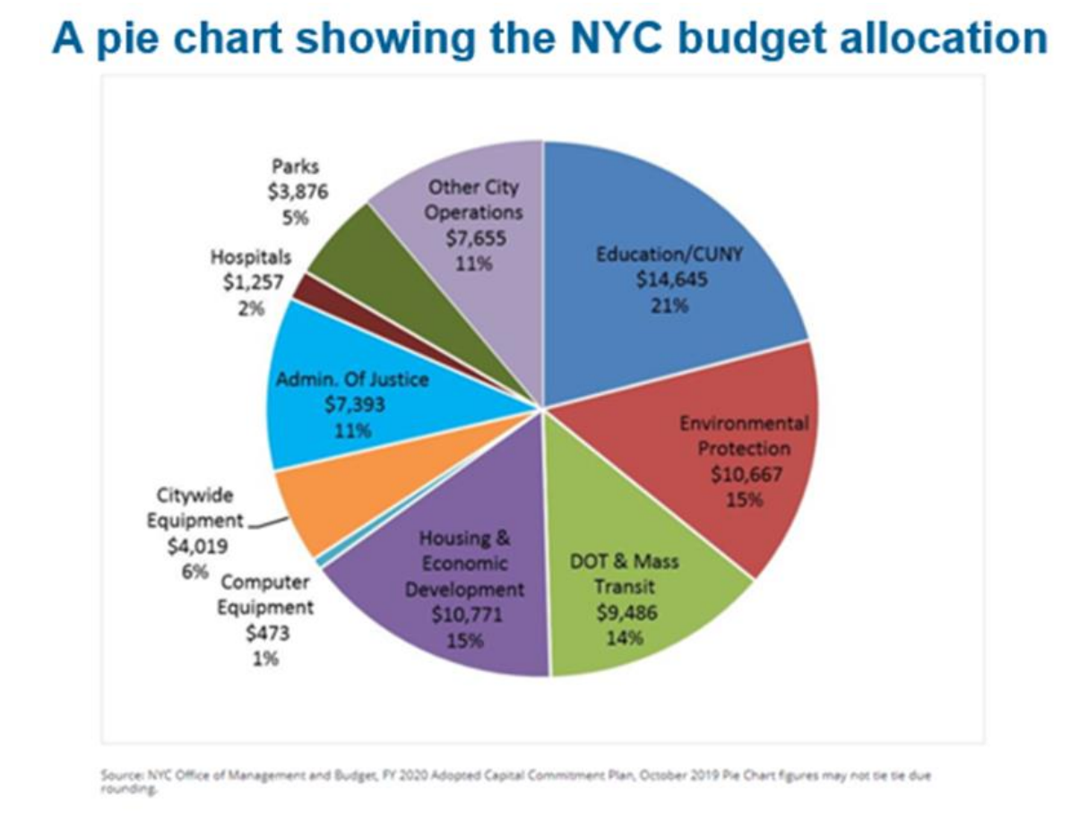

1. Give two reasons why the bar chart makes for a better choice than a pie chart to visualise the New York City funds allocation.

**A.** First is **Comparison** so easy by **a bar chart** which is ideal for comparing precise values of **categories**, such as New York City's fund allocation like Parks, hospitals, Computer equipment, etc. easy to find information and eye point is quick to find. However, when the numbers are close together or there are too many categories, a **pie chart** might make it **challenging to compare** the sizes of the slices appropriately.

Second, **Handling multiple data** with a **bar chart is better** for years or time series as it simplifies comparison of allocation changes, unlike pie charts which require separate charts for each time period.

2. Why would you choose a bar chart over a column chart to visualise the New

York City funds allocation?A. There is not much difference between a bar chart and column chart but normally for easy getting data from chart depending on data and categories because a column chart uses vertical bars to indicate category values, which is appropriate for **short labels** or **smaller categories** with smaller bars, as opposed to **a bar chart**, which uses **horizontal bars** to **represent category** values with **long labels** and **long categories.**

**Activity 4 – Using Trend Lines**

Consider the two scatter charts and related trendline and regression statistics shown

below and on the next page, for Anscombe’s data sets. The estimated regression

equations and related R-squares for both data sets are identical.Does fitting a line to the data appear to be a wise choice for both data sets? Discuss your answer.

1. We discussed answer in workshop live but I didn’t understand only I understand relationship between two variables, often achieved through linear regression, doesn’t it?